3- Digit number in the Abacus

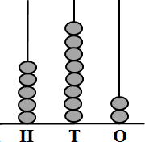

Before, After and Between
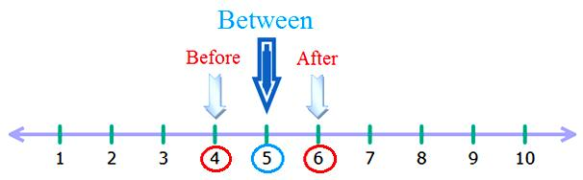
25Save
On the number-line –
number 4 is before number 5,
number 6 is after number 5,
number 5 is between number 4 and 6.

